Design And Development Of Manually Operated Multipurpose Bi-Piston Hydraulic Press
Mr Siddappa P Nª, Abhilash G^{b}, SahityaG^{c}, Vikas B S^{d}
ªAsst.Professor,Dept of Mechanical Engineering, JSS academy of technical education, Bangalore-560060, India
^{b}Dept of Mechanical Engineering, JSS academy of technical education, Bangalore-560060, India
^{c}Dept of Mechanical Engineering, JSS academy of technical education, Bangalore-560060, India
^{d}Dept of Mechanical Engineering, JSS academy of technical education, Bangalore-560060, India

ABSTRACT:
It is practically difficult for most of the small scale industries to financially accommodate high-end presses with high tonnage. Those machines also require a huge amount of factory space and suitable infrastructure.An attempt has been made in order to overcome the above mentioned problem by designing and developing a manually operated hydraulic press using the principle of Pascal’s law. Manually operated presses can be used as an alternative in those operations which do not require a huge amount of tonnage. It is affordable and also has multiple benefits with variety of applications.
Keywords— Hydraulic press,manually operated, Bi-piston, Pascal’s law.

Full Paper:
A forming press, commonly shortened to press, is basically a machine tool that changes the shape of a workpiece by the application of pressure. It is generally used for applications like punching of sheets, bending and removal of bend in metal rods, coining,etc.
Presses are basically classified into three types based on their working mechanism. They are Mechanical, pneumatic and hydraulic presses.
Primarily, mechanical press transforms the rotational force of a motor into translational force that performs the pressing action. Therefore, the energy in a mechanical press comes from the motor. In a mechanical press, the application of force varies in magnitude throughout the distance of the stroke.
Pneumatic presses are those which performs the action of pressing by utilizingthe pressure generated by compressed air.Air is forced into a tube which fills the air and applies pressure that causes the press to move downwards.
A hydraulic press is a device that uses a cylinder with a working fluid to generate a compressive force. The cylinder houses the piston onto which the force is transmitted. This force is used for the pressing action on the workpiece.

2. Principle

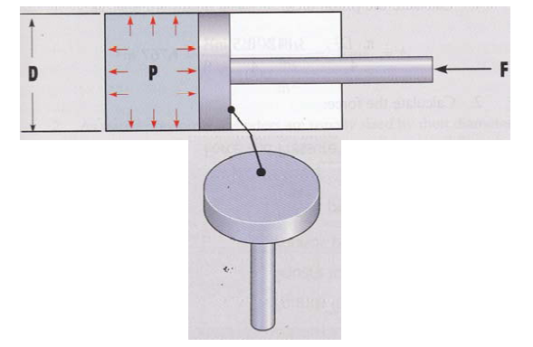

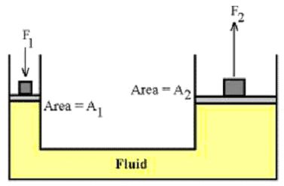

Fig.1 Pascal’s law
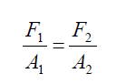
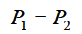

It basically works on the principle of Pascal’s law which states that the pressure exerted onto a confined fluid is transmitted and acts equally in all directions at the same time, and acts uniformly at right angles to the containing surfaces.

3. Material selection
3.1 Aluminium
Grade: Al 2024-O
Properties: Available in sheets, tubes rods, and many other preformed profiles, Lightweight, Non-ferrous, Low melting point, Pale silvery colour.
Compressive strength σ_{c}=186 N/mm²
Advantages: Good strength to weight ratio, Aesthetic appealwell – mirror finish, can be recycled economically, Corrosionresistant, Malleable andDuctile, Strong anddurable, Impenetrable to air, light, andmoisture.
3.2 Mild Steel

Grade: ASME SA 36

Properties: Tough, ductile and malleable, Ferrous, Available in sheets, wire, tubes rods, and many other preformed profiles, Dull dark grey colour – discolours easily due to corrosion.
Tensile strength σ_{t}=410 N/mm²
Compressive strength σ_{c}=410 N/mm²

Advantages: Very strong, easily joined, andcan be heated to very high temperatures.

4. Construction

In its simplest form, it consists of a single barrel or cylinder fitted with two pistons. End caps are provided to the cylinder fitted with suitable seals to hold all the components together and prevent leakages. The piston rod where load is applied is fitted with a plunger whose diameter is smaller than that of the piston rod.
The piston and plunger rods are moved using suitable screw rods. The other end of the piston rod that is used to perform work is fitted with the required tool depending upon the type of application. A pressure gauge is placed such that the hydraulic fluid pressure inside the cylinder is indicated on its dial. This entire unit is then made to rest upon a suitable frame depending upon its purpose of usage.

5. Operation
In the first half cycle, torque is applied to the screw rod which is coupled to the effort side piston by a suitable connector. Due to the torque applied on screw rod, the effort side piston gets displaced by the amount of pitch moved on the screw rod. This develops an initial pressure in the cylinder which causes the movement of the load side piston and the same pressure is used to grip the job.
In the second half cycle, torque is applied to a screw rod coupled to the plunger. The torque applied on the screw rod moves the plunger to certain extent which pierces the oil confined between two pistons. As a result, the pressure of the oil in the cylinder is increased. This pressure gets added to the initial pressure which produces a higher tonnage which can be used for various industrial applications.
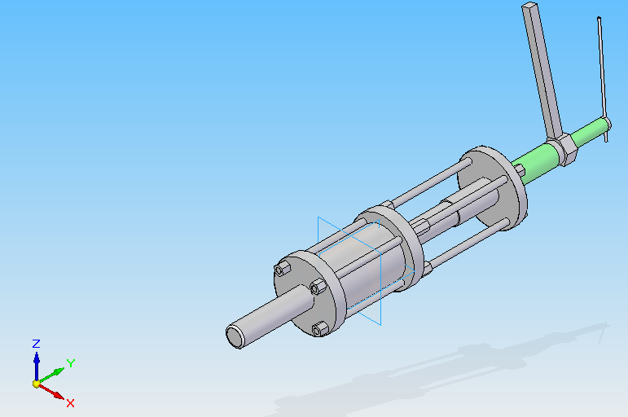
Fig 2: 3D view of Hydraulic Press Assembly
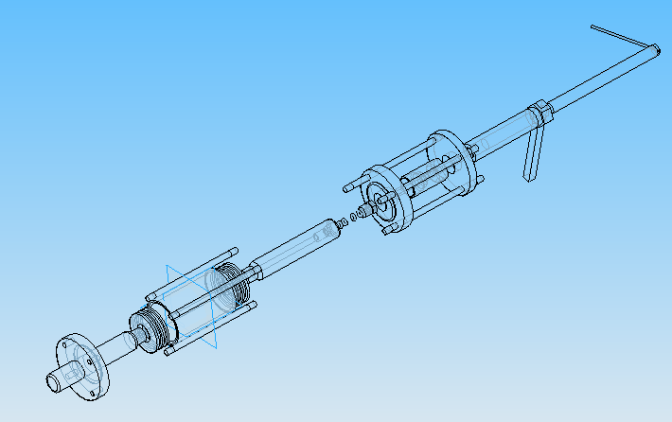Fig 3: Exploded view of the assembly
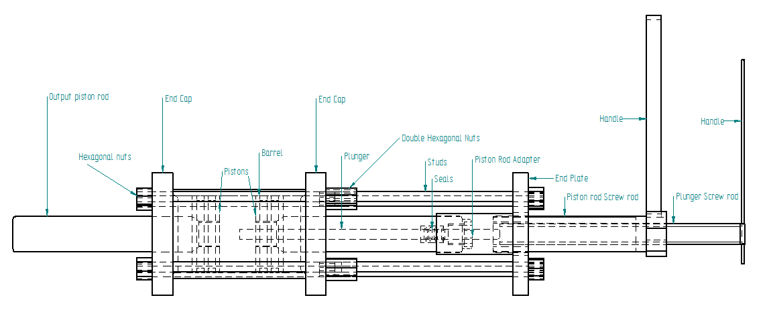
Fig 4: 2D Drawing of the assembly
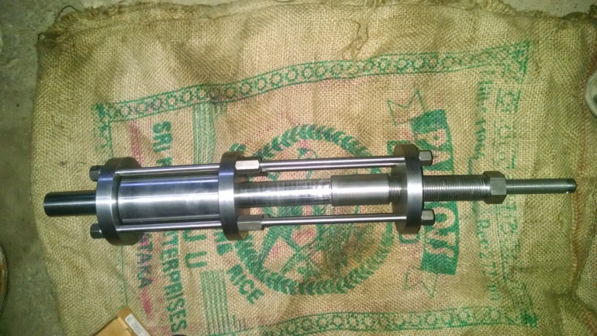Fig 5: Photo of the assembly
6. Design Calculations
Consider the example of punching operation for Al- 6061 T-6
Ultimate shear strength of Al-6061 T-6= 207N/mm²
Diameter of punch = 20mm
Thickness of Al sheet = 1mm
Total force required for punching = π x d x t x σ_{u}
= 13006N
Considering the operation on other materials of higher shear strength, the press has been designed to produce an output force of 100,000N (10 tonnes).
By observing the pressure gauge reading the operator can limit the hand movement to get the required tonnage depending upon the application and material.

6.1 Calculation of total tonnage
Consider 50N is applied on to a rod of length 200mm which turns the screw rod.
The work done by applying 50N = the work done by amount of pitch moved on the screw rod.
6.1.1 Pressure developed due to piston
W₁=W₂
F₁ X S₁= F₂ X S₂
F₁= 50N
S₁= circumference of the circle traced by the rod= πD=π x 400mm =400π
F₂= output force of the piston
S₂= pitch on the bigger screw rod= 3mm
50 x 400π = F₂ x 3
F₂= 20943.95 N
Therefore pressure developed due to piston
$$P_{1}=\frac{F_{2}}{A}$$
$$P_{1}= \frac{20943.95}{\frac{π}{4}X {75}^{2}}$$
P₁= 4.74 N/mm²
6.1.2 Pressure developed due to plunger
F₁ X S₁= F₃ X S₃
F₃= output force due to plunger
S₃= pitch of smaller screw rod= 1.5mm
50 x 400π = F₃ x 1.5
F₃= 41887.9 N
Therefore pressure developed due to plunger
$$P_{2}=\frac{F_{3}}{A}$$
$$P_{2}= \frac{41887.9}{\frac{π}{4}X {75}^{2}}$$
P₂ = 9.48N/mm²
Total pressure acting = P₁+ P₂ = 4.74+9.48
= 14.22N/mm²
Total tonnage = P X A
=14.22 X 0.785 X 75²
= 62790.18 N or 6.27 tonnes
Assuming 10 tonnes (98066.5 N) of force acting , maximum pressure is given by
$$P=\frac{F}{A}$$
$$P=\frac{98066.5}{\frac{π}{4} X {75}^{2}}$$
= 22.20 N/mm²
6.2 Design Calculation for components
6.2.1 Barrel /cylinder:
Bore diameter= 3”= 76.2mm
After machining the bore diameter is 75mm
Cylinder wall thickness from lame’s equation for ductile materials is given by
$$h=\frac{d_{i}}{2}(\sqrt{\frac{σ_{t}}{σ_{t}-2P}}-1)$$
Where,
h= cylinder wall thickness
d_{i} =inner diameter of barrel
$σ_{t}$ = tensile strength of MS (ASME SA 36)=410 N/mm²
P= maximum pressure developed
$$h=\frac{75}{2}(\sqrt{\frac{410}{410-\left(2 X 22.2\right)}}-1)$$
h =2.21mm
For safe design thickness of 5mm is taken and FOS=2
6.2.2 Piston rod:
Assume 10 tonnes (98066.5 N) of force acting on piston rod.
Stress acting on the rod is given by
$$σ_{c}=\frac{F}{A}=\frac{F}{\frac{π}{4}x d^{2}}$$
F= force in Newtons
A= area of piston rod
$σ_{c}$ = compressive strength of MS (ASME SA 36) =407.7 N/mm²
d= diameter of piston rod
$$407.7=\frac{98066.5}{\frac{π}{4} X d^{2}}$$
d = 17.5mm
To accommodate plunger, diameter of 35mm is considered for safe design and FOS=2
6.2.3 Piston
Thickness of the piston is given by
$$h=0.65(\sqrt{\frac{F X log\frac{d}{d_{0}}}{σ_{d}}})$$
h=Thickness of the piston
F= force in Newton
$σ_{d}$=compressive strength ofAl 2024-O= 186 N/mm²
d= outer diameter of piston
d_{o} = diameter of piston rod
$$h=0.65(\sqrt{\frac{98066.5 X log\frac{75}{35}}{186}})$$
h= 13.02 mm
For safe design length of the piston is taken as 27mm and FOS=2
6.2.4 Stud:
Consider 10 tonnes (98066.5 N) of force acting on four studs.
Hence force on each stud = $\frac{total force}{4}$
$$=\frac{98066.5}{4}$$
= 24.516 KN
To calculate diameter of stud,
$$σ=\frac{F}{A}$$
F= force in Newtons
A= area of stud
$σ$ = tensile strength of MS (ASME SA 36)=407.7 N/mm²
d= diameter of stud

$$410=\frac{24516.62}{\frac{π}{4} X d^{2}}$$
d= 8.72mm
Therefore, Astandard size of 10mm is selected.
6.2.5 End cap:
Thickness of end cap is given by
$$h=k_{1}d (\sqrt{\frac{P}{σ_{C}}})$$
h= thickness of end cap
k₁ = constant to be multiplied for a fixed circular MS plate.
d= diameter of end cap
P= max pressure developed
$σ_{c}$ = compressive strength of MS
$$h=0.35 X 120 (\sqrt{\frac{22.2}{407.7}})$$
h= 9.80mm
For safe design, thickness of 20mm is selected.
7.Conclusion
A Hydraulic press of 8 tones has been designed and manufactured along with a supporting H-frame structure.
The system has been designed to be multi-functional with clamping, coining, punching of sheet metal, pressing and cable cutting as some of the applications with minor adjustments in die design.
It has got the advantages of being economical, simple, compact, safe to operate, having a high power to weight ratio and has no complex circuits.
The H-frame structure has been analyzed using Solidworks software to test its strength and safety, and the results were found to be satisfactory.

7. References
- Fluid Power with Applications 6thEdition,AnthonyEsposite,Dorling Kindersley india Pvt Ltd
- Design of machine elements- 1 by J.B.K. Das, P.L. Srinivasa Murthy,
- revised and enlarged edition-2012.
- Design of machine elements- 2 by J.B.K. Das, P.L. Srinivasa Murthy,
- revised and enlarged edition-2012.
- Machine design data handbook volume-1 and volume-2 by Dr.K.Lingaiah.
- http://en.wikipedia.org/wiki/Hydraulic_press
- http://www.dakecorp.com/products-detail.asp?page=Hand-Operated
- http://en.wikipedia.org/wiki/Pascal%27s_law

